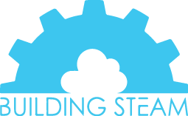 SUMMER CAMP POLICY/LIABILITY WAIVER

REFUND POLICY: Refunds will not be issued for non-attendance at a scheduled class.

MAKEUPS: Makeups will only be offered for full duration of camps. If a student misses one or more days of camp there will be no makeup.

PHOTOS: I, ________________________ , understand that photos will be taken at the event and posted to the Building Steam website and social media. I am in full knowledge that if I do not want my child’s photos on either, I must send an email to dan@buildingsteamnow.com.

RELEASE / INDEMNIFICATION: I hereby, in consideration of such benefits and other good and valuable consideration received, consent to the above listed participation and release absolutely, forever discharge, hold harmless and covenant not to sue Building Steam, and camp location, its directors, employees, agents, volunteers, and affiliates from any and all present or future liability, claims, demands, actions or rights of action, whether asserted by me or a third party arising out of my child's participation in the event activities (the "Claims"). I agree to indemnify and hold harmless Building Steam and camp location for any such Claims brought by me or a third party from any costs associated with defending or litigating such claims, including but not limited to attorney fees, costs and legal expenses.

Parent/Guardian Signature ______________________________ Date _________________________

Parent/Guardian Print Name ______________________________

